

**Assignment 02 – Twitter Service**

1. Develop a simple twitter service that implements any Twitter API to programmatically create, retrieve and delete a Tweet in the Twitter Sandbox environment. e.g., ads-api-sandbox.twitter.com https://developer.twitter.com/en/docs/ads/general/overview/ads-api-sandbox.html (Links to an external site.)
2. Develop a simple Web UI that implements your service and demonstrates the functions.

The Twitter documentation is here:

<https://developer.twitter.com/en/docs/ads/general/guides/getting-started>

(Links to an external site.)

<https://developer.twitter.com/en/docs/developer-utilities/twitter-libraries>

(Links to an external site.)

Also. the example code in the Twitter Websocket Blueprint Example may be helpful.

See here:

<https://github.com/apache/camel-examples/tree/master/examples/camel-example-twitter-websocket>

**NOTES**:

Include in the source code comments, i.e. who wrote which code.

Submit a Word Document of UI interaction, with screenshots of

Good Coding.

**Source Code for assignment is at Git Hub repo:-**

<https://github.com/harsh2000hp/CMPE272TeamMaverick>

* **Team Members:-**

1. Harsh Patel
2. Phani Sai Ram Munipalli
3. Piyush Mamidwar
4. Priya Gupta



A simple web-based user interface called "**Maverick Twitter Tweets**" has been created to post, retrieve, and delete a tweet from Twitter.

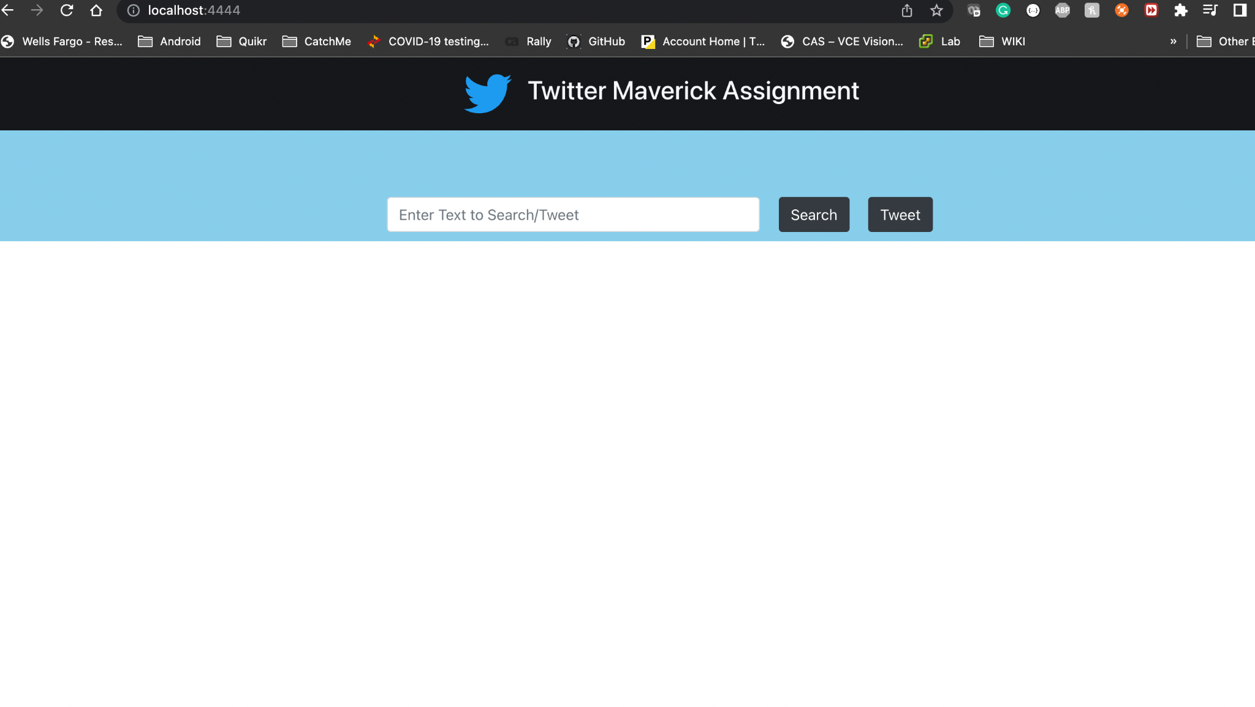

1. **Search Status on Twitter:-**

For searching any tweet on Twitter, the user can type **status** in the given text area to search for the tweet on Twitter.

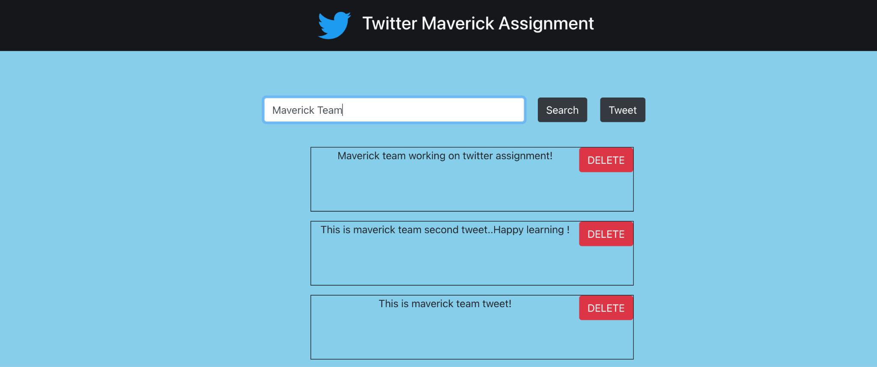

**2. Post Status on Twitter:-**

To post a tweet to Twitter, the user types status in the given text area.

The tweet “Happy coding from the maverick team!.” is posted on Twitter and, under *beneath it will show on the web page.*

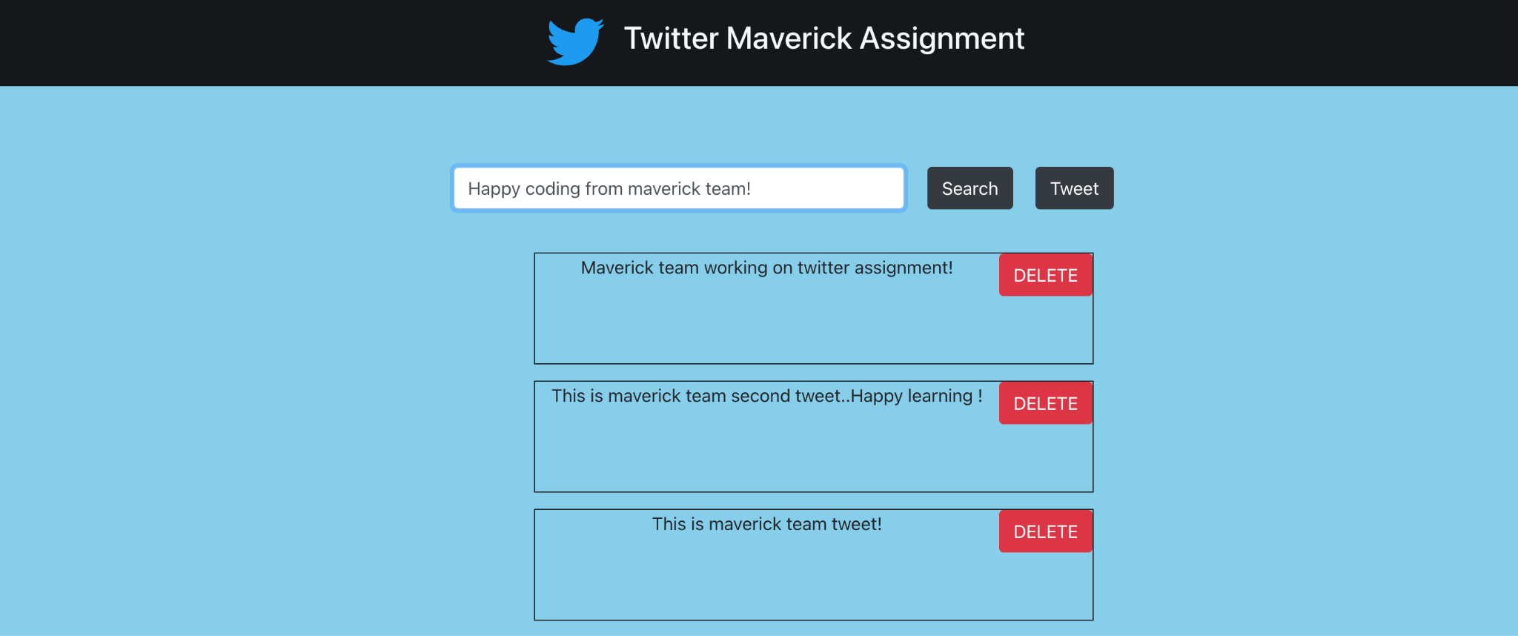

**WEB-UI**

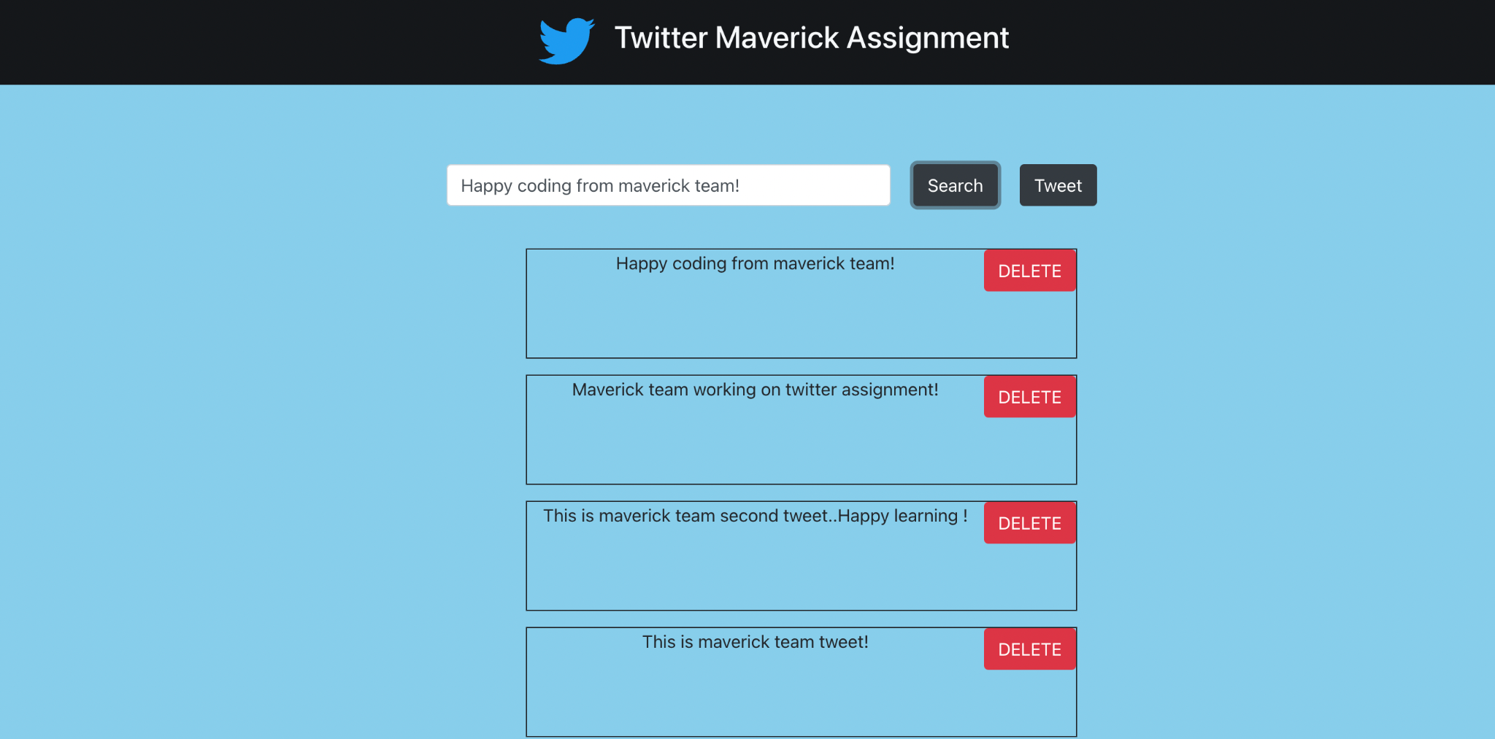

**TWITTER**:

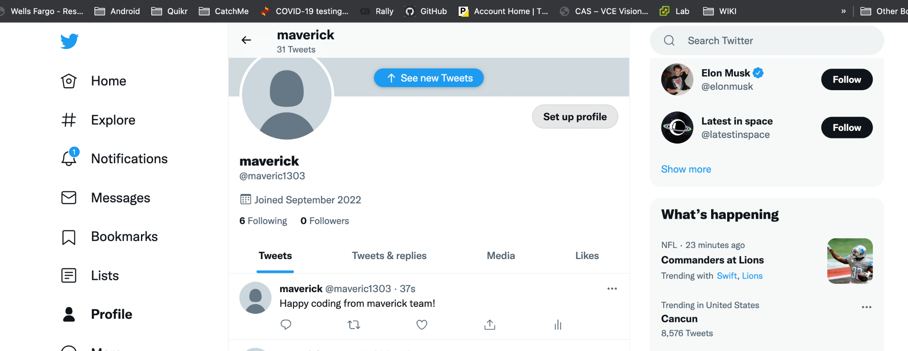

**3. Retrieve status from Twitter:-**

When the user will click on "Fetch tweets" to get all tweets from Twitter, it then appears on the screen.

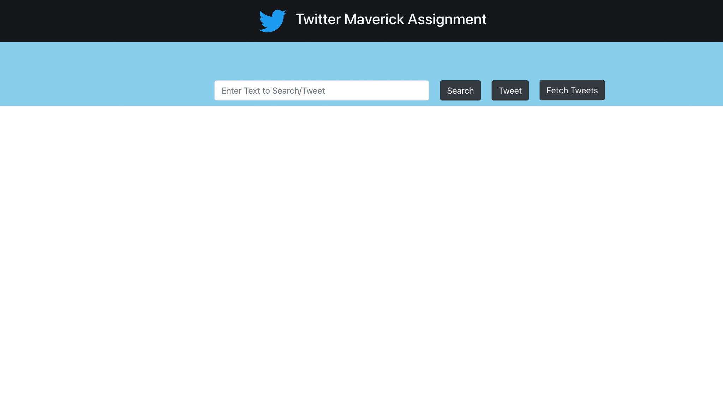

**WEB-UI** will display all tweets after fetching it from Twitter.

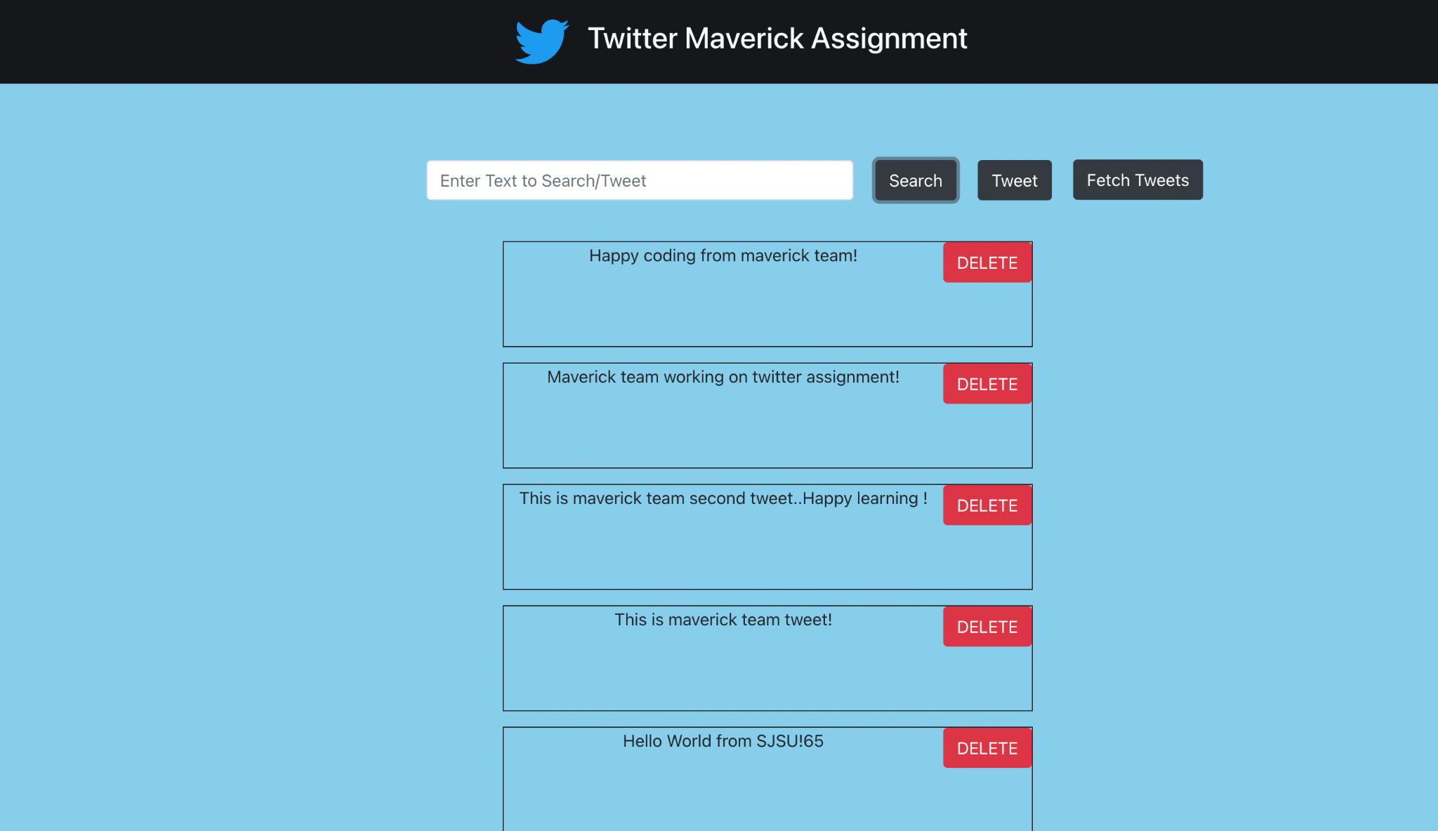

**Twitter screenshot showing all tweets of a user** :

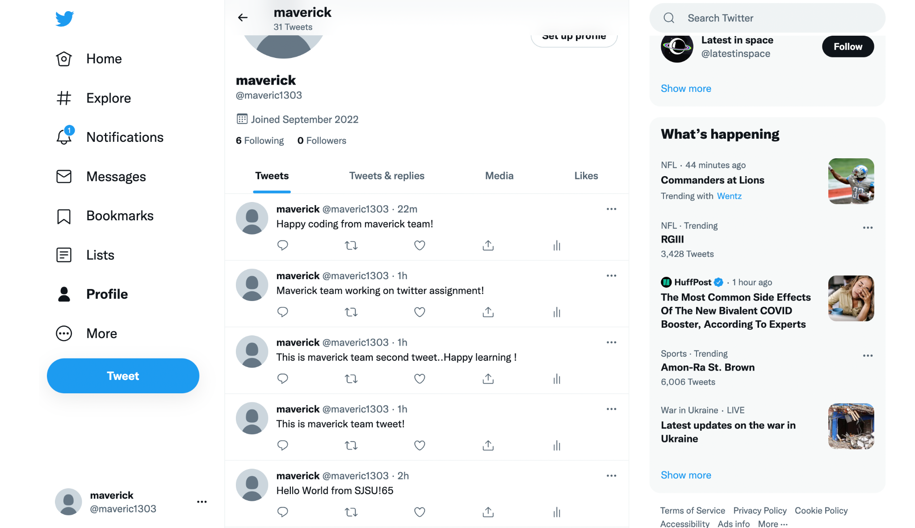

**4. Delete status on Twitter:-**

To remove a tweet, a user clicks the Delete button next to it. Send the following tweet: "This is maverick team tweet!” is already retrieved for deletion. The tweet is removed from both the web page's section and the Twitter page by clicking the delete button.



Once the user will click on Authorize button, it will redirect to the Twitter page where the user can verify whether that tweet got deleted or not.

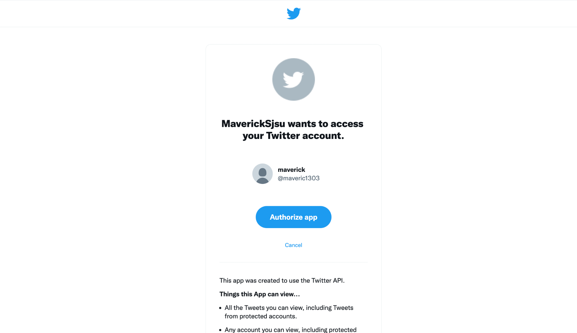

**Twitter Id: 1571582660136554498 which the message “**This is maverick team tweet!” now no longer exists on Twitter.

